# Experiment No.: 5

**Aim**

Familiarisation of Linux Commands

# CO2

Perform System Aministration tasks

# Procedure

1. read – Too read the content of the line, we use read command. This line read the command into a variable
   1. read



* 1. read variable1 variable2 variable3 -Declare variables to store data





* 1. To read contents through multiple lines we use”\” at the end of each line.

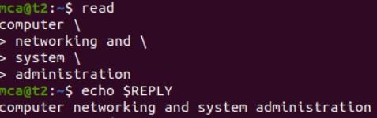

d)read -p “[Prompt message]” -Prompt user to enter data

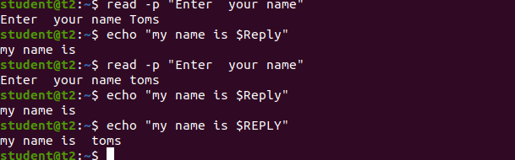

d)read -n limit -p - Specifies the limit



1. read -s -p - it gives the security(hides the data)



1. wc -To display number of lines, number of words, number of bytes, filename
   1. wc filename

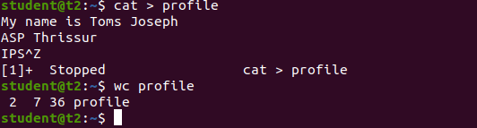

* 1. wc -l filename
  2. wc -m filename



* 1. wc -c filename



* 1. wc -w filename



* 1. wc -L filename – Print the length of the longest line



1. more - The more command is similar to cat command to display the content. The only difference is that in case of larger files cat command output will scroll of your screen while more command display output one screenful at a time.
   1. more filename.txt

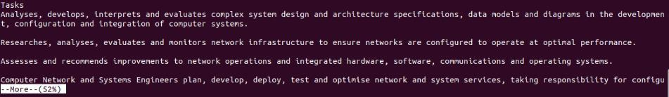

b)more +[number] filename.txt





c)more +/ [word] [filename.txt] - This option is used to search the string inside your text document. We can view all the instances by navigating through the result.

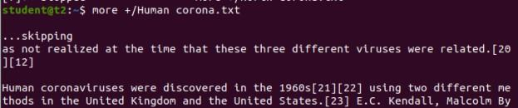

d)more –d filename.txt – Helps the user to navigate according to the instruction.”Space key” to continue and “q” to quit.

# Result

The program was executed and the result was successfully obtained. Thus CO2 was obtained

.